|  |
| --- |
|  |



**19 April 2013** **The Weekly Bulletin of Rotary Club of Kathmandu Mid-Town** **Bc-19.4/012-13**

**District : 3292 Web: www.rotarymidtown.org.np Club Id : 26776**

**APRIL IS MAGAZINE MONTH**

Rotary International today claims a unique communications network — The Rotarian, the official English language magazine of Rotary International and 31 Rotary World Magazine Press magazines that are independently produced in their countries across the globe. They are published in more than 20 different languages, distributed in 132 countries, and have a combined circulation of 769,000.

**Special Issue of Breakfast Chatter**

**Dedicated to late Rtn Pratap Malla**

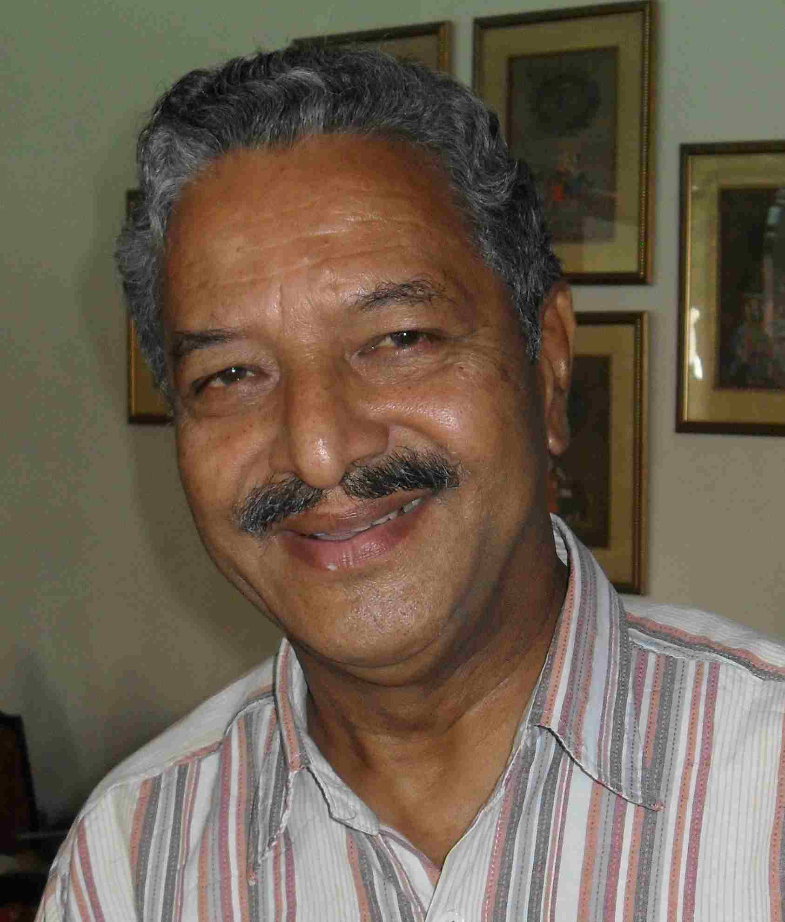

 

**Tribute to late Rtn Pratap Malla**



Date of Birth : 18 December 1941

Civil Engineering Degree, College of Military Engineering, Poona, India

‘A’ Level - UK

Training and certification

Senior International Defense Management Course - US Naval Post Graduate School, USA

Command and General Staff - Fuehrungs Akademie der Bundeswehr, Germany

Career Courses - Various Courses up to the battalion level

Officer’s Basic Training - Royal Military Academy Sandhurst, UK

Membership

Member - Nepal Engineers’ Association

Fellowship (Life Member) - Indian Institute of Engineers, India

Member - American Society of Civil Engineers, USA

Decoration/Medals

Order Nation of Merit France : Sept 1983

Trishakti Patta 3rd class : Dec 1984

UN Medal for Peace UNIFIL : Dec 1987

Shreepad : Dec 1987

Gurkha Dakshin Bahu 2nd class : Dec 1993 .

Professional experience:

Military command & general staff with over 20 years in army service;

Service experience of command & staff functions,

including ladership and management from the Platoon to the Brigade level.

Experience in setting up a new Mountain Roads Department in the Army Engineering Branch.

Commanding an Engineer Battalion, including Training Center Company

within the battalion for the combat engineer training for NCO’s.

In Home Country:

Engineer Training Center 1971 - 1972

Engineer Battalion Commander 1981 - 1985

Secondment to Budhanilkantha School - Special Duty to HRH Crown Prince 1985 -1987

Asst. Brigade Commander, # 5 Brigade, Western Nepal

Chief Engineer - Royal Nepalese Army 1990 - 1994

Overseas - United Nations Service:

a) Battalion Commander NEPBATT XIII, UNIFIL (Lebanon) : 1987 - 1988

b) Chief Building Management Services, UNOSOM II (Somalia) : Mar 1994 - Mar 1994

c) Chief Building Management Services, UNOMIL (Liberia) : Mar 1997 - Nov 1997

d) Chief Engineer, Support Center, MINURSO (Western Sahara) : Nov.’97 - March 2004

e) Officer in charge, General Services Section, MINURSO : Sept 2001 - March 2004

f) Officer-in-charge, Administration (in absence of the Administrative Officer) Sept 2002 - March 2004



**In Rotary**:

He was introduced to Rotary Club of Kathmandu Mid-Town in August 2006

as a guest of PP Gopal SL Kakshapati.

Induction on 27 August 2006 amidst a program

during the ICM on Membership Development.

Director, Community Services in 2007-08

Chairperson, Service Projects Committee in 2008-09

President-Elect as well as Contact Person of MG projects in 2009-10

Club President in 2010-11

It was his sole contribution in getting RCC Lele established,

RCC Gorkha and RCC Lamjung in process,

now RI certificates already received.

Chairperson, District RCC Sub-Committee in 2012-13



***Service Above Self !***

On a holiday trip to California, USA, Pratap visited his son Bruno Malla,

who work in a private company in San Francisco;

he convinced the company management and got private donation amounting to US $ 1,000

which he used to support computer training facility for

Shree Saraswoti Higher Secondary School, Lele, by providing 20 computer tables.

He knew RC Patan was providing 20 computers to the School,

he supplemented training facility by providing computer tables.

Such was the spirit, determination and dedication for community service !

In another trip to the USA,

he visited Rotary Clubs in San Francisco, convinced Rotarians how a little donation

would help villagers in Nepal, got their commitments,

developed projects of drinking water and public toilets in Lele which finally got implemented as

MG projects.

Gorkha-Lamjung Girl Child project to support school-going girl students in two districts,

a MG project with primary support of RC Darmstdt Bergstrasse, Germany

was almost dead, had it not been the effort of Pratap with his network of

retired army personnel in the districts, he got the project survived, personally took pain in its implementation and the project went on for three years so well

that the Germany Club decided to continue for another three years under WCS funding

as MG fund was not available for the same project to continue further.

And so on and on … …

in all the projects he was involved in.

He was so self-inspiring, so dedicated, so determined …



**Condolence messages:**

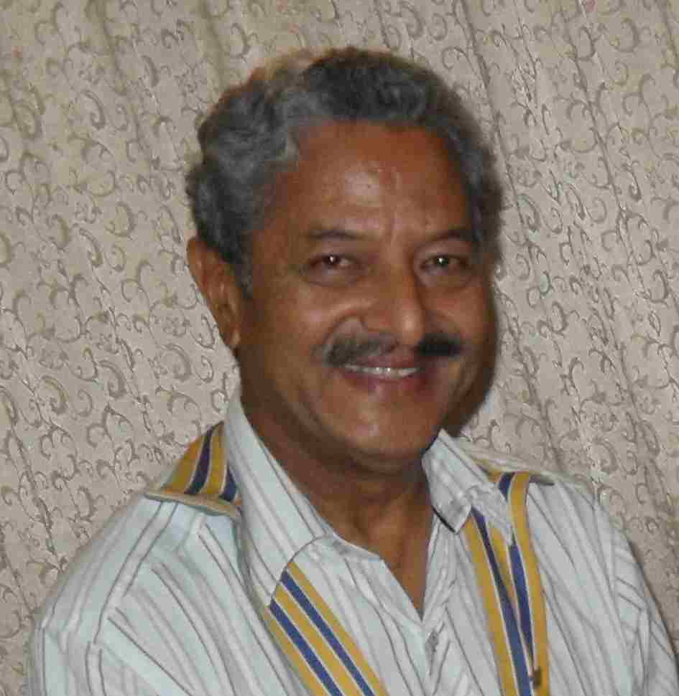

Many Mid-Towners sent in their condolence messages -

"It is to inform you, with heavy heart, of the sad and untimely demise of our energetic Rtn PP Pratap Malla on 4.4.2013, Thursday. Let us wish Heavenly peace to his departed soul and our deep-felt condolence to his family. Our Friday Club meeting, tomorrow will be held in a normal way, but with a sad note of condolence."

*- President Devendra*

"Rtn Pratap was always one hundred percent committed to any of the tasks and initiatives he undertook.  He was passionate about projects he took responsibility for, particularly those related to the rotary cause.  He was inspiring to all in his level of enthusiasm and dedication. Many will agree that his energy and dynamism was motivating to all around him.  Above all he was proud to be a Rotarian and found a deeper purpose in his life through 'service over self' in reaching out and serving others."

*- Rtn Neeva Pradhan*

It  would not be over stating, but very much in place, to say that our Past President late Brigadier General (retd.) Pratap Singh Malla was a very enthusiastic, innovative, resourceful and hard working person who was adored by all of us  Rotarians in our Club. For this very reasons, he was equally appreciated by fellow Rotarians of other Clubs of our District. His selfless dedication to duties and enthusiasm to do the social works, was much appreciated by all of us.

Rtn Pratap was always busy trying to do some thing for the Club. It was always relaxing and inspiring to see Rtn Pratap in our club meetings with his jeal and enthusiasm. He was a person who could not be ignored by any one. His pleasing personality always made all of us relaxed in his company. If I had to remember late Pratap I would remember him as a person who was least perturbed with problems but always faced it with determination to solve it, an army general who performed very well and earned respect from all quarters, a true Rotarian who put service before self and earned admiration and love from all. He would be missed by all of us and mostly by the needy ones for his social service. His invaluable contributions to the service of needy people and institutions, has positive impact in uplifting the image of our Club amongst the Rotary clubs of RI District 3292 in particular, and also in international Rotary clubs in general . He would always be remembered for the inspiring leadership to our Club and many innovative and productive  social works he initiated during his presidency.

His sudden demise is an irreparable loss to us Mid-Towners . It  has shocked all of us and we mourn his untimely death with praying for his soul to rest in Peace in Heavenly Abode. My wife, Mrs. Euhazur Thapa and I express our deepest sympathy to all members of the bereaved family, in particular to Mrs. Nabina Malla and her sons and their families.

A true and befitting tribute to late Rtn Pratap, would be for all of us Kathmandu Mid-Town Rotarians, would be to give continuity to the community service projects he started and also to complete the ones he had just initiated. Salute to you, Rtn Pratap. Though you are not with us in person, you will always be with us in our heart !

*- Rtn. Lt.Gen.(retd) Krishna NS Thapa*

I’m so sad, together with my husband Luigi, because of the demise of your and our beloved Pratap.

We are still abroad and, then, we cannot be physically present, but the loving memory of him is and forever will be with us.

I’ll never forget, in fact, his strong commitment always joined with his kindness.

He was helping and supporting me a lot during my first steps in Rotary world, as an elder brother, with passion, giving me a good example in each concrete action and spiritual approach.

With all my most sincere, heartfelt sympathy to you and your family.

*- Rtn Sharmila Mainali*

My heartfelt condolences on the sudden demise of our dear Past President Pratap. Got the sad news of Pratap Ji’s demise, I was shocked to read it, as during my time as president we shared lots of work in Rotary, where PP late Rtn. Pratap always stunned all of us with his great dedication to Rotary and his strong engagement in supporting Lele VDC and later Gorkha/Lamjung.  He also could convince others to work with him to do great social work. May his lifetime work inspire now also others to follow his path. With heartfelt condolencs to the family members.

*- Rtn Walter*

Having passed quite some time as "neighbor" but also sharing lots of work in Rotary, where PP late Rtn. Pratap always stunned me with his great dedication to Rotary and helping others, also outside of Rotary.  His dedication brought us to Lele VDC and the Fire brigade among many other in Gorkha or Kathmandu. I hope our involvement in the "Mission Impossible" will not rest now, but go forward in his memory.

we are saddened by the news of the demise of our good friend. May his soul rest in peace and our heartfelt condolencs to the family members.

*- Rtn Navyo Eller*

I am indeed sad to hear this sudden news of the demise of PP Pratap Malla. I did not even know that he was sick. I got the news late and sorry that I missed to join you all. My heartfelt Condolences to the members of the bereaved family. May God Almighty grant them peace and strength to bear this irreparable loss  of their loved one.

*- Rtn Rokaya*

I am very saddened to hear of the untimely passing away of our dear friend Pratap Malla under whose Presidentship of our Club I have had the pleasure of working as a Joint Secretary.

I guess I will have to live with the regret of not having called on him and his wife during his sickness!  
If you find the opportunity, please convey my deepest condolences to Mrs. Pratap Malla- I pray that God give her the strength to bear with her irreparable loss!

*- Rtn Buddha*

The spirit of PP Pratap Malla will live on in our hearts and as an inspiration to all that Rotary stands for. I personally learned so much from him, as I had the honour to serve on the Board when he was President. His enthusiasm, efficiency, charm and effectiveness will not be forgotten. My most sincere condolences to his family for his most untimely loss.

*-Rtn Lisa Choegyal*

Late Past President Brigadier General Pratap Singh malla was a man with vision, knowledge and courage. His dynamic and able leadership could bring success in every projects under-taken by our club. let us pay sincere tribute to him by continuing " Bishnumati Rehabilitation Project (Mission Impossible)",which was initiated under his leadership

- *Rtn Amar Panta*

What moves through us is a silence, a quiet sadness, a longing for one more day, one more word, one more moment. We do not understand why you left the earth so soon, or why you left before we were ready to say good-bye. We, like everyone else, are shocked and fail to understand.

You still live among us for your life gave us memories too beautiful to forget. It's the little things, the small, everyday occurrences that is remembered: the laughs, the stories. the smiles. We know that no words can ease the pain and loss that the family is feeling, the least we can offer is to be around to help through this difficult period.

- Rtns Anand / Dr Lekha



**Condolence messages cont'd:**

Many Rotarians from other Clubs of RI District 3292 sent in their condolence messages –

What a sad news, I couldn't believe this. In this moment I stand firmly by the President and all the members of RC Kathmandu Mid-Town to pay tribute to late Past President, General Rtn. Pratap Malla. I wish I were there.

- *Rtn Jagan Gurung, PP, RC Pokhara*

I read mail with utter shock and sadness. Unbelievable, but probably this is what called destiny. I personally, and on behalf of all the members of RC of Kathmandu North East, express our heart felt condolences and pay our sincere tributes to the departed soul. May his soul rest in peace. Also, pray that God bestows enough strength to the bereaved family to bear this un- repairable loss.

- *Jayanta Berma, President, RC of Kathmandu North East*

I am stunned to hear the sad news of death of Rtn. Gen. Pratap Malla from this mortal world. We have lost a true Rotarian from this earth. My hearty condolence for this irrepairable loss. I pray the Almighty to give strength to the bereaved family and to all Rotarians to bear this tragedy. Let the departed soul rest in peace!

*- Rtn. Dr. Badri raj, Past President, RC Budhanilkantha*

I am sad to hear sudden news of RCC Chair PP Pratap Malla. My heartfelt Condolences to the all members of the bereaved family and RC Kathmandu Mid Town. I think we lose one dynamic Rotarian leader from RI District 3292.

- *Rajendra Subedi, President, RC Rupandehi*

I was greatly shocked to learn about the sudden and untimely death of our respected Gen.Pratap Malla. It is an irreparable loss indeed. His positive attitude always admire me to do good in every walk of life. He was the one who guided me on the time of difficulties in the Army Service and UN service. We all must obey the God's will and we should take heart and bear the calamity patiently. I have full confidence that God will grant him peace to the departed soul and we all must follow his path of goodness to all as a true Rotarian, and give strength and courage to bear this loss.

- *Rtn Janak Prakash Thapa, President, RC, Patan Durbar Square*

We were shocked to hear the sad news on Rtn Gen Pratap's untimely demise. He was a very good friend of mine and a man of word. May his soul rest in peace with God!

- *Rtn KB Chettry, RC New Road City*

We the family of Rotary club of Kasthamandap are profoundly grieved on sudden sad demise of PP Rtn Gen Pratap Malla. Rotary movement has lost a dedicated ideal Rotarian like PP Rtn Gen Pratap Malla, is also a great loss to Rotary movement. We express our heartfelt condolence to Rotary club of Kathmandu Mid-Town and earnestly request to please convey our heartfelt sympathy to his bereaved family. We pray almighty for the eternal peace of the departed soul.

*- Rotary club of Kasthamandap family*

Very sad to hear the news.May the departed soul rest in peace in heaven.I offer my heartfelt condolences to the bereaved family members,friends & the members of RC Kathmandu-Midtown.

- *Rtn Govind Singh (Lucky Singh)*

Very sad news. I knew late Brig Pratap from the time he was with the Brigade of Gurkhas in Hong Kong when he was a Lt Col. Then again back in Nepal and then with Rotary Club. He is a great loss to the Rotary family, a truly dedicated and kind person who had great ability.  Our condolence to the family and to members of your club..

- *Major Yambahadur Gurung, PP RC The HImalayan Gurkhas*

I, on behalf of all our club members express our deepest condolences on the sad demise of PP Pratap Malla. We pray to God for the eternal PEACE of the departed soul.

*- Er. Dhruba Thapa, President, Rotary Club of Kantipur*

It is very to sad loose one of the very dedicated Rotarian and a good personality indeed. We pay our deepest tribute to him and pray for peace to his soul and condolence tot he berieved family.

*- Rtn Badan, PP, RC Mount Everest*

On behalf of rc tripureswor, i would express our heartfelt condolence on the sad demise of pp pratp malla. We pray to god almighty for the heavenly abode of his departed soul.

*- Madan, President, RC Tripureshwor*

We are saddened to know the demise of your energetic Past President Pratap Malla on 4.4.2013 Thursday. Our  heartfelt condolence to bereaved family & our prayer to God to let the departed soul rest in peace at Heaven.

- *Rtn Beni Gopal Mundara, RC Biratnagar*

I am really shocked to hear the sad news of Rtn Gen Pratap's untimely demise. He was a very dedicated Rotarian of Nepal who always stood for providing service to the needy. As an Assistant Governor of your club for the year 2009 -2010, I had an opportunity to work with him and I still remember of his works in the villages that your club had adoped to do various types of social works. He was always very active and worked very hard to implement effectively all the works that were carred there. May his soul rest in peace with God!

- *PP Timsina, RC Dillibazar*

**Condolence messages cont'd:**

It was a pleasure to attend your club meeting this morning.  Though the occasion was very sad, I was inspired by the stories of Rtn Pratap Malla and I look forward to hearing more of them. He sounds like he was quite an inspirational and dedicated servant of those in need.

- *Colin, RC Capitol Washington*

I was really shocked by the news of the death of Pratap Malla.

Thanks to Rotary I had the chance to meet Pratap the first time I went to visit your Club together with other Rotarians of my Club in 2008. Together we tried to overcome the difficulties that there were in that period in obtaining funds from TRF to finance our project in Lele and I was very happy when he decided to visit Ravenna and our Club in the summer 2010.

Lastly we celebrate together in Kathmandu the achievement of the project during his presidency year. So I really feel that the death of Pratap is like the loss of a bit of my life.

- *Rtn Maurizio Montanari, Rotary Club Ravenna, Italy*

It is a very deep sorrow for the whole Rotary Club Ravenna to be acquainted with the sudden death of Rtn Pratap Singh Malla.

We had the opportunity to appreciate his kindness as well as his perseverance on occasion of the humanitarian project that our two Clubs carried out in Lele village some years ago.  
Some Rotarians of our Club went to Kathmandu before the beginning of the project and, some years later, when the project finished. In the meantime, Pratap surprised us coming, in 2011 June, to Ravenna and visiting our club together with his wife Nabina and his son Bruno.

So really we considered Pratap a true friend and a genuine Rotarian.

On behalf of Rotary Club Ravenna, let me finally express our genuine sympathy with Rotary Club Kathmandu Mid-Town on this tragic loss.

- *Remo Di Carlo, President of Rotary Club Ravenna*

**Tribute to late Rtn Pratap Malla**



*Service Above Self* does not know such borders. When we serve, the impact is not limited to

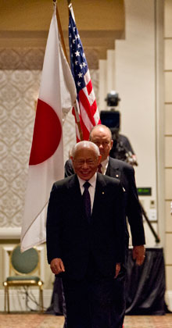

our community, or the community we are helping. We are not only helping the young, or the

elderly, or this school, or that orphanage. When we serve, we are helping all of humanity.

The effects of what we do go on and on.

**RI President Sakuji Tanaka**

Rtn Pratap Malla :

Click here ⇩



A thought for the day:

***For certain is death for the born***

***And certain is birth for the dead;***

***Therefore over the inevitable***

***Thou shouldst not grieve.***

*Bhagavad Gita*

Great quotes:

***Our death is not an end if we can live on in our children and the younger generation.***

***For they are us, our bodies are only wilted leaves on the tree of life.***

Albert Einstein



NB: Send any informations/photos that may be of interest to the Club or Rotarians in general to

BC Editor: RR Shrestha email: rryesrr@gmail.com

## 19 April 2013 The Weekly Bulletin of Rotary Club of Kathmandu Mid-Town bc-19.4/012-13